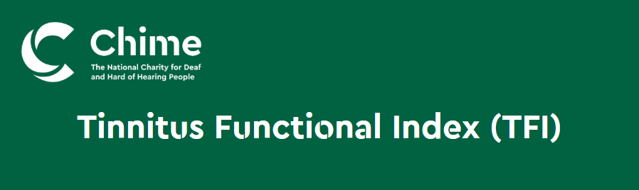

Instructions on how to use this form:
Please read each question below carefully. To answer a question, select ONE of the numbers that is listed for that question. Tinnitus Functional Index (TFI) was developed by Meikle and Henry et al (2012) and is recommended to be used in the UK by the NICE guideline 2020.
Your name:
Email address:
Phone number: ______________________________________________________________
Address: ___________________________________________________________________
Birthdate: __________________________________________________________________
Have you had a Hearing test in the past year?
Yes ☐
No: ☐
Do you need an ISL interpreter?
Yes ☐
No: ☐
Are you a current/ previous Chime client?
Yes ☐
No: ☐
Preferred date of program: Choose an item.
I. Over the Past week…

- What percentage of your time awake were you consciously AWARE of your tinnitus?
Never Always
0% | 10% | 20% | 30% | 40% | 50% | 60% | 70% | 80% | 90% | 100%

- How STRONG or LOUD was your tinnitus?
Not At All Extremely
0 | 10 | 20 | 30 | 40 | 50 | 60 | 70 | 80 | 90 | 100

- What percentage of your time awake were you ANNOYED by your tinnitus?
None of the Time All of the Time
0% | 10% | 20% | 30% | 40% | 50% | 60% | 70% | 80% | 90% | 100%

SC. Over the Past week…

- Did you feel IN CONTROL of your tinnitus?
Very Much Never
0 | 1 | 2 | 3 | 4 | 5 | 6 | 7 | 8 | 9 | 10

- How easy was it for you to COPE with your tinnitus?
Very Easy Impossible
0 | 1 | 2 | 3 | 4 | 5 | 6 | 7 | 8 | 9 | 10

- How easy was it for you to IGNORE your tinnitus?
Very Easy Impossible
0 | 1 | 2 | 3 | 4 | 5 | 6 | 7 | 8 | 9 | 10

C. Over the past week how often did your tinnitus interfere with...

- Your ability to CONCENTRATE?
Did not Interfere Completely Interfered
0 | 1 | 2 | 3 | 4 | 5 | 6 | 7 | 8 | 9 | 10
- Your ability to THINK CLEARLY?
Did not Interfere Completely Interfered
0 | 1 | 2 | 3 | 4 | 5 | 6 | 7 | 8 | 9 | 10

- Your ability to FOCUS YOUR ATTENTION on other things beside your Tinnitus?
Did not Interfere Completely Interfered
0 | 1 | 2 | 3 | 4 | 5 | 6 | 7 | 8 | 9 | 10

SL. Over the past week...

- How often did your Tinnitus make it difficult to FALL ASLEEP or STAY ASLEEP?
Never Always
0 | 1 | 2 | 3 | 4 | 5 | 6 | 7 | 8 | 9 | 10

- How often did your Tinnitus cause you difficulty in getting AS MUCH SLEEP as you needed?
Never Always
0 | 1 | 2 | 3 | 4 | 5 | 6 | 7 | 8 | 9 | 10

- How much of the time did your tinnitus keep you from SLEEPING as DEEPLY or as PEACEFULLY as you would have liked?
Never Always
0 | 1 | 2 | 3 | 4 | 5 | 6 | 7 | 8 | 9 | 10

Over the past week how much has your tinnitus interfered with...

- Your ability to HEAR CLEARLY?
Did not interfere Completely interfered
0 | 1 | 2 | 3 | 4 | 5 | 6 | 7 | 8 | 9 | 10

- Your ability to UNDERSTAND PEOPLE who are talking?
Did not interfere Completely interfered
0 | 1 | 2 | 3 | 4 | 5 | 6 | 7 | 8 | 9 | 10

- Your ability to FOLLOW CONVERSATIONS in a group or at meetings?
Did not interfere Completely interfered
0 | 1 | 2 | 3 | 4 | 5 | 6 | 7 | 8 | 9 | 10

R. Over the past week how much has your tinnitus interfered with...

- Your QUIET RESTING ACTIVITIES?
Did not interfere Completely interfered
0 | 1 | 2 | 3 | 4 | 5 | 6 | 7 | 8 | 9 | 10

- Your ability to RELAX?
Did not interfere Completely interfered
0 | 1 | 2 | 3 | 4 | 5 | 6 | 7 | 8 | 9 | 10

- Your ability to enjoy "PEACE AND QUIET"?
Did not interfere Completely interfered
0 | 1 | 2 | 3 | 4 | 5 | 6 | 7 | 8 | 9 | 10

R. Over the past week how much has your tinnitus interfered with...

- Your enjoyment of SOCIAL ACTIVITIES?
Did not interfere Completely interfered
0 | 1 | 2 | 3 | 4 | 5 | 6 | 7 | 8 | 9 | 10

- Your ENJOYMENT OF LIFE?
Did not interfere Completely interfered
0 | 1 | 2 | 3 | 4 | 5 | 6 | 7 | 8 | 9 | 10

- Your RELATIONSHIPS with friends, family and other people?
Did not interfere Completely interfered
0 | 1 | 2 | 3 | 4 | 5 | 6 | 7 | 8 | 9 | 10

- How often did your tinnitus cause you to have difficulty performing your WORK OR OTHER TASKS, such as home maintenance, school work or caring for children or others?
Never had Difficulty Always had Difficulty
0 | 1 | 2 | 3 | 4 | 5 | 6 | 7 | 8 | 9 | 10

E. Over the past week...

- How ANXIOUS or WORRIED has your tinnitus made you feel?
Not at all Extremely
0 | 1 | 2 | 3 | 4 | 5 | 6 | 7 | 8 | 9 | 10

- How BOTHERED or UPSET have you been because of your tinnitus?
Not at all Extremely
0 | 1 | 2 | 3 | 4 | 5 | 6 | 7 | 8 | 9 | 10

- How DEPRESSED were you because of your tinnitus?
Not at all Extremely
0 | 1 | 2 | 3 | 4 | 5 | 6 | 7 | 8 | 9 | 10

